Customer shopping behavior
Analysis Report
Sanadi Liyanage
Business & Data Analyst
1. Project Overview
End-to-end Business Intelligence project analyzing 3,900 customer transactions to uncover purchasing patterns, customer segments, product preferences, and subscription behavior. The analysis evaluates key factors such as spending patterns, discounts, customer ratings, seasonal trends, and payment preferences to identify actionable insights and support data-driven marketing, product, customer engagement, and strategic business decisions.

2. Dataset Summary
-Rows: 3,900
-Columns: 19
- Key Features: - Customer demographics (Age, Gender, Location, Subscription Status)
- Purchase details (Item Purchased, Category, Purchase Amount, Season, Size, Color)
- Shopping behavior (Discount Applied, Promo Code Used, Previous Purchases, Frequency of Purchases, Review Rating, Shipping Type)

3. Exploratory Data Analysis using Python
Data Loading
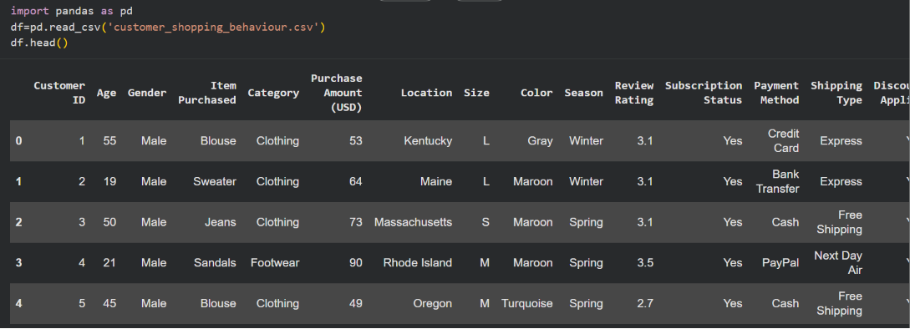

Initial Exploration
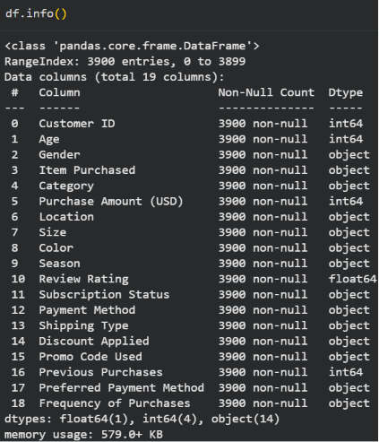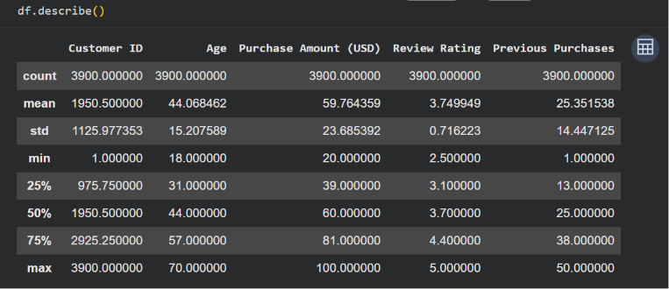

Checking for misssing data
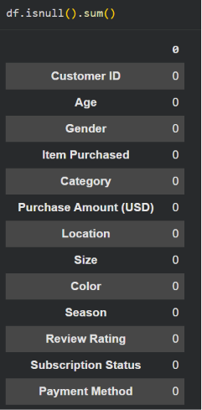

Column Standardization:
- Renamed columns to ‘snake case’ for better readability and documentation.

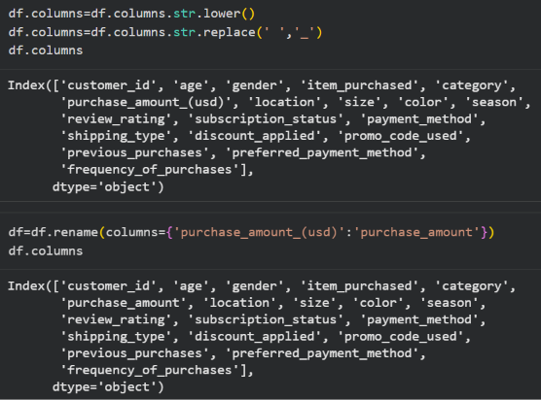

Feature Engineering:
- Created ‘age_group’ column by mapping customer ages.
- Created ‘purchase_frequency_days’ column from purchase data.

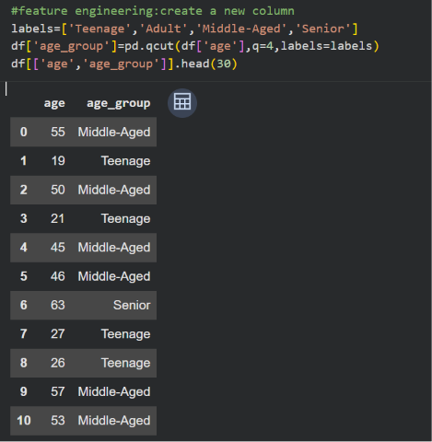
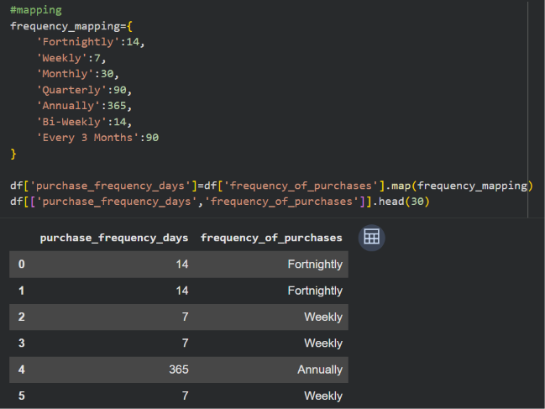

Data Consistency Check:
- Verified if ‘discount_applied’ and ‘promo_code_used’ were redundant, dropped ‘promo_code_used’.
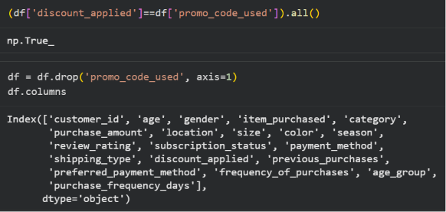

4. Data Analysis using SQL Queries
Total Revenue
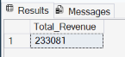

Average purchase amount
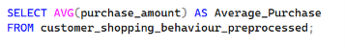
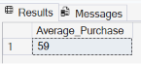

Minimum purchase amount
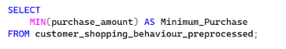
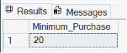

Maximum purchase amount
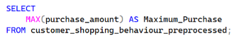
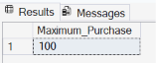

Total purchases by age groups
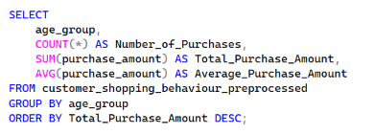
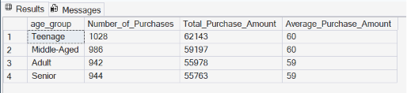

Total purchases by gender
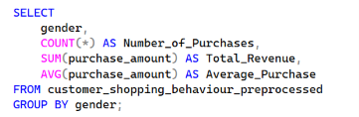
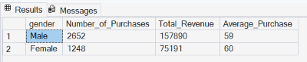

Most popular product categories
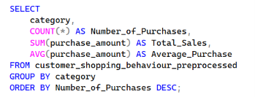
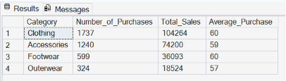

Purchasing during certain seasons
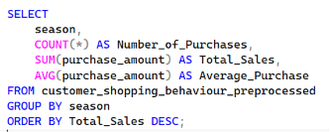
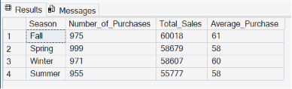

Discount effect on purchasing decisions
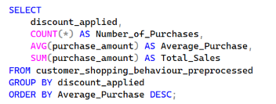
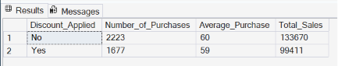

Ratings/Reviews effect on purchasing decisions
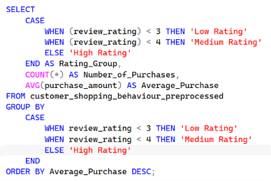
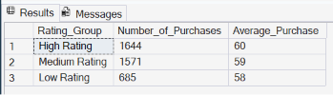

Most used payment methods
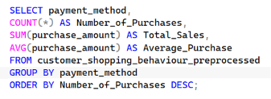
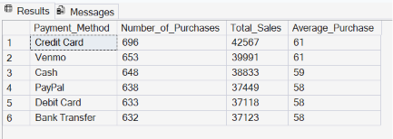

Frequency of purchases
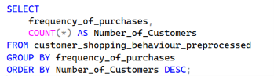
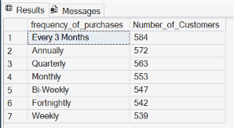

What makes customers come back and purchase again?

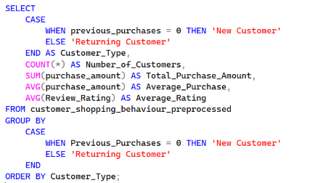
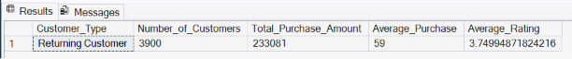

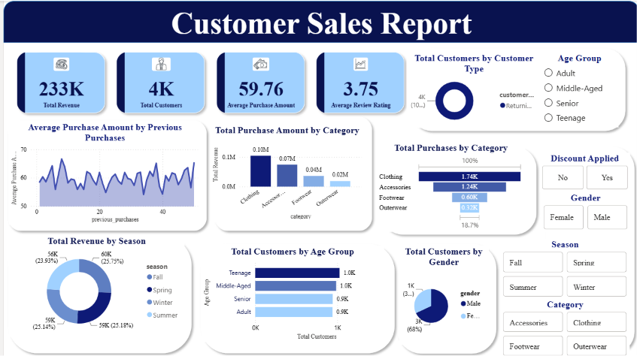
5. Dashboard in Power BI

6. Business Recommendations
- Cut back on discounts - Non-discounted orders actually average more ($60 vs $59) and bring in more total sales. Discounts aren't paying off — use them only for specific goals (like clearing slow stock), not everywhere.
- Push Clothing and Accessories harder, fix Outerwear - These two categories bring in 76% of sales. Outerwear is way behind ($18.5K vs $104K for Clothing) — bundle it with popular items or rework its pricing.
- Watch customer ratings closely - Customers who rate their purchases highly buy more and spend more. When someone leaves a low rating, follow up with them quickly (support, replacement, etc.) before they leave for good.
- Make card/digital payments smoother - Credit Card and Venmo users spend more per order ($61) than Bank Transfer or Debit ($58). Make those payment options easier and consider small perks for using them.
- Get customers buying more often - Most people only shop once every 3 months. Send reminder emails or offer a subscription/auto-refill option to shorten that gap.
- Grow the female customer base - Only 32% of orders come from women, even though they spend just as much per order as men. There's room to grow here with better targeted marketing.

